**WMWI**

 **Walton Manor** **WI**  **Registered charity 1119651**

**The National Federation of WIs campaign to improve women’s and family’s lives**

**Monthly Newsletter: MAR 2023: No 190**



[www.waltonmanorwi.co.uk](http://www.waltonmanorwi.co.uk)

**President:** Caroline Coleman - 07850 830858

**Secretary:**  Clare Wildish - 01865 556018

**Treasurer & Vice President:** Liz Jennings - 07717756338

**Next meeting**

**TUESDAY 14th MARCH 2023**

**AT**

**St Margaret’s INSTITUTE**

**Matt Williams will Give A talk about The Samaritans**

**(Matt Williams was Director of the Oxford Branch of The Samaritans from 2010 – 2022. He is passionate about outreach and speaking to Communities about the work of the Charity)**

**FOLLOWED By WMWI AGM**

**7.30 for 8 p.m. Start**

.

**FUTURE EVENTS :**

**KNIT & NATTER**

**Date: Tuesday 21st March 2023**

**Time : 7 – 9 p.m.**

We knit, sew, darn, embroider and natter over a cuppa. All WMWI members are welcome. Just turn up. The hostess is Catherine Dobson.

[**dobsoncatherine1@gmail.com**](mailto:dobsoncatherine1@gmail.com)

Tel :01865 515436

**WMWI WALKS**

The next walk will be on Wednesday 22nd March when hopefully the weather will be warmer. For further details contact Hilary Godfrey [hilary@godfrey.uk.net](mailto:hilary@godfrey.uk.net)

**CHERWELL GROUP MEETING**

**Date: Wednesday 19th April 2023**

**Time : 7.30 p.m. (Doors open 7 p.m.)**

**Venue : Cassington Village Hall, The Green, Cassington, OX29 4AX**

The speaker will be Sir Muir Gray and his talk is “How to reduce your risk of dementia and live better, for longer”.

The tickets are £4 (to include refreshments) and tickets can be bought at the next WMWI meetings.

**PAST EVENTS :**

**LAST WMWI MEETING :**

**Date : Tuesday 14th February**

**Andrew Humphries (Antique Restorer and Specialist Cabinet Maker) talking on “Restoring the Queen’s Furniture … and Other things”**

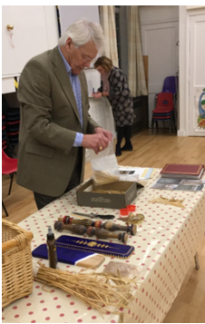

Our speaker was Andrew Humphries, a retired maker and restorer of furniture. He “rambled through his career” (his words not mine!) Having been taught woodwork by his father, some forty years ago, he discovered that his passion was restoring furniture. In the early days he made harpsichords, organs and traditional furniture. He was a lecturer for some 25 years. He was invited by the palace to restore some Russian conservatory furniture belonging to the Queen, which was kept at Frogmore House. There were 13 pieces in all which had been given by Czar Nicholas II to the late Edward VII in 1904.

As you will see from the photographs they were in a bad state of repair.

He then demonstrated how he split barley stalks, which would then have been soaked and steam ironed. From this he was then able to cut the various shapes needed to make the patterns. These shapes were then glued onto the freshly painted furniture. It took him about 3 – 4 years but as you will see from the before and after photos, the result was amazing.

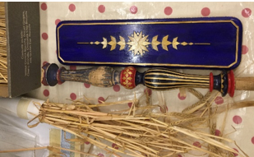

Andrew was a lecturer at Rycotewood College in Thame. That college was given by Czar Nicholas 11 of Russia, who was the last Czar of Russia.

Andrew worked for David Linley and through Linley he got the job for the queen. It was interesting to hear the details of finding the right paint with original pigment because underneath the paint was gesso which has to be covered by oils. His wife had to cut some shapes with a scalpel as his fingers were too big!

--------------------------------------------------------------------

**WEBSITE**

The WMWI website is at [www.waltonmanorwi.co.uk](http://www.waltonmanorwi.co.uk)

Do look at it. A Suggestions tab is included.

**WMWI MCS DATABASE**

This database links to NFWI, and ensures that you receive WI Life and other information. This can only be done if we keep it up to date. So please tell Caroline Coleman if you change your address or email, or wish to receive the campaigns e-newsletter. [carolineecoleman@btinternet.com](mailto:carolineecoleman@btinternet.com)