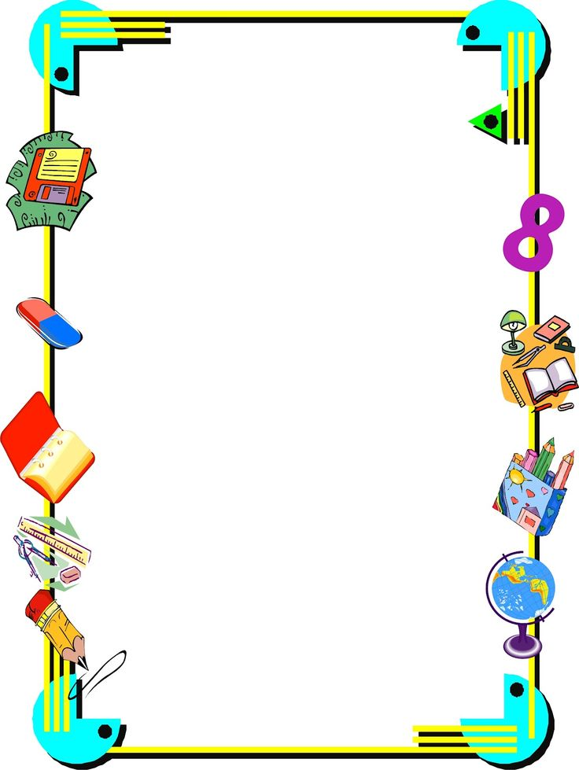
WMWI
The National Federation of WI’s campaign to
improve women’s and family’s lives

Monthly Newsletter: SEPTEMBER : 195
www.waltonmanorwi.co.uk

President: Caroline Coleman -07850 830858
Secretary: Clare Wildish – 01865 556018 Walton Manor WI Treasurer & Vice President: Liz Jennings – 07717 756338 Registered charity 1119651

NEXT MEETING – WMWI
WHEN Tuesday 12th September WHERE St Margaret’s Institute
Polstead Rd

TIME 7.30pm for 8pm start
MARIELLA BLISS Italian Cookery Demo
She will share her passion and experience.

LAST MONTH’S MEETING
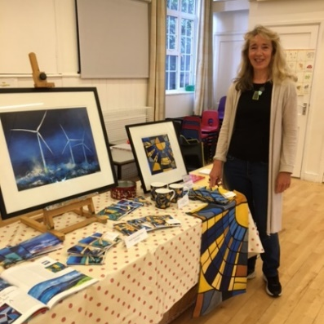

Our speaker for the evening was Sarah Bond, a local artist now living in Cumnor . She grew up by the sea and became inspired by the wonderful turquoise seas around the Cornish coastline. She mainly paints in oils and focused on seascapes especially painting stormy seas. Sarah described
her method of painting starting. First the whole canvas is primed with acrylic Gesso. For a

landscape painting she would start with the sky and using photos which she had previously taken.
Our members were then invited to have a go and were given basic instructions. There were some very interesting results.

Some three years ago she became interested in wind energy and she began to think much more about climate change. Sarah decided to visit Westmill Wind Farm on the western edge of Oxfordshire where there are five towering turbines. This lead her on to start painting
abstract offshore wind turbines.

Her husband had one these abstract paintings, called Winds of Change as his Zoom backdrop during the first lockdown in 2020 as he gave presentations etc and the Global Wind Energy Council saw it, and then commissioned her to do a painting for them for the UN Climate Change Conference COP26 held in Glasgow last November It depicts wind turbines standing aloof in the ocean and is called. Our Hope For Years To Come. Sarah had brought some of her artwork and post cards for us to see.

LUNCH CLUB
Walton Manor WI’s Lunch Club met at The Talbot Inn,
Eynsham on Wednesday 23rd August. Eight of us had a very convivial lunch and were very pleased with the food and the service at the inn.
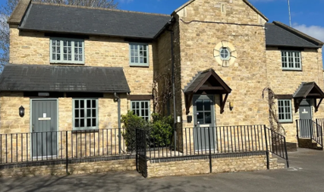

The next lunch meeting will be on Wednesday 25th October - venue to be announced.
Put the date in your diary !

FUTURE EVENTS
The Knit and natter group will meet on
Tuesday 19th September
KNIT AND NATTER
FROM 7 – 9PM at
92 Lonsdale Rd OX2 7ER

Bring along any knitting, darning, crochet, sewing, embroidery – and above all YOURSELF for a good natter and a cuppa! Catherine Dobson

OFWI UPCOMING EVENTS FROM OXFORDSHIRE INSPIRES
Singing into Christmas with Stages Theatrical
When : 14th December 19.00 – 21.00
Where St Peter & St Paul Church, West Way,
Botley, Oxford OX2 9JY
Cost : £13 - £15 (non-refundable)
Tickets available from 2nd October
This will be a lively evening with songs from stage shows and musicals. In fact, why not use this as an opportunity to have some fun, dress up and try to out “sparkle” these lively artists.

ALSO
CRUISING INTO CHRISTMAS
WHEN Thursday 7th December
WHERE London (Greenwich to Covent
Garden)
COST £67 – WI Member
£71 – non WI Member
Back by popular demand this event is action packed. Coach ride to Royal Greenwich where there is an opportunity for lunch, browsing in the market or to visit the National Maritime Museum and the Queen’s House (both free entry). Then meeting our Blue Badge Guide at Greenwich Pier as the sun sets, to embark for an hour-long cruise to Westminster Pier, passing well known landmarks all lit up like a mini- Manhattan. The coach will meet us at the pier for a tour of the London lights before taking us to our restaurant for a Fish and Chip supper before heading home

