

**WMWI**

**The National Federation of WI’s campaign to**

**improve women’s and family’s lives**

**Monthly Newsletter: OCTOBER : 196**

[**www.waltonmanorwi.co.uk**](http://www.waltonmanorwi.co.uk)



**President:** Caroline Coleman -07850 830858

**Secretary:** Clare Wildish – 01865 556018 **Walton Manor WI**

**Treasurer and Vice President** : Liz Jennings – 07717 756338 **Registered charity 1119651**



**NEXT MEETING** – WMWI

**WHEN** Tuesday 10th October

**WHERE** St Margaret’s Institute

Polstead Rd

**TIME** 7.30 for 8pm start

**JOHN CALDICOTT -**

**Daisy’s Story – 1930’s Unmarried Mothers**

Former Foundling Hospital pupil, Coram Governor and Hon Secretary of the Old Coram Association John Caldicott tells his story

**LAST MONTH’S MEETING**

Mariella Bliss was born in Italy where she would spend many hours watching and learning cooking skills from her grandmother. In particular she learnt the art of making wonderful pasta. Her grandmother did not have a pasta machine and made the pasta just rolling the dough many times, until you can almost see through it. She used a huge rolling pin the width of the table!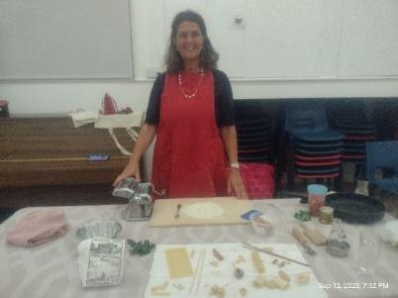

There is a different method to making pasta, depending on which part of Italy the wheat comes from. For instance in south Italy no eggs are used but in mid Italy they would use eggs.

The right type of flour is very important. Semolina flour is often the preferred ingredient

Mariella then showed us how to make pasta using 100grams of Wessex Mill flour and 1 large egg

The flour was placed on to a clean board, She then made a well in the middle of the flour, and then put the egg into the middle. Using a plastic short scraper, she gradually brought the flour into the middle until eventually she ended up with a soft dough. During this process she would continually keep scraping the board clean.

The dough would then rest for ½hour.

Then the magic began as she kept feeding it repeatedly through the pasta making machine. Using the various settings on the machine, we watched the dough transform into a long, transparent strip.

You can cut it into strips or many different shapes and use it then and there. If you wish to keep it, you need to leave to dry for five to six hours. It will keep for a month.

If you want to buy dried pasta, she recommended you buy a good quality one, the paler the pasta the better

Mariella then made a fresh tomato sauce and invited members to taste it with some bread.

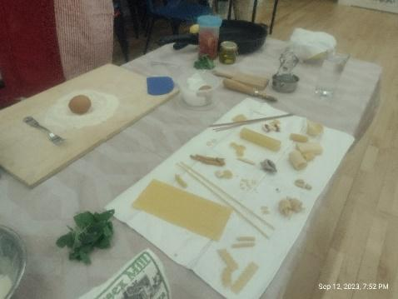

**FUTURE EVENTS**

**Walton Manor Lunch Club**

The next meeting of the lunch club

will be on

**Wednesday 25th October**

at 12.30 p.m.

at **The Trout Inn**,

195 Godstow Rd, Wolvercote

Oxford OX2 8PN.

Please reply to Catherine Dobson

d[obsoncatherine1@gmail.com](mailto:obsoncatherine1@gmail.com)

01865 5154 36

by Sunday 22nd October if you wish to come

**Walton Manor Knit and Natter**

The next Knit and Natter meeting will be

on Tuesday 17th October

from 7 – 9 p.m. at Catherine’s

92 Lonsdale Road, OX2 7ER.

Bring along your knitting, sewing, darning etc

and enjoy a coffee/tea and a good natter.

Illustrated are the baby clothes some of us have

made for babies in South Africa I can provide a

pattern and you could start by knitting simple

little bootees or mittens. Do come!

**GROUP MEETING**

**WHEN WEDS 18TH OCT at 7.30PM**

**DOORS OPEN 7PM**

**WHERE Cassington Village Hall**

**TICKET £4**

**SPEAKER - AL SYLVESTER**

**My life in the RAF Mountain Rescue Service**

**WMWI THERE WILL BE A RAFFLE AT OUR MEETING SO DO BRING YOUR PURSES**

**OFWI UPCOMING EVENTS FROM OXFORDSHIRE INSPIRES**

Singing into Christmas with

Stages Theatrical

When : 14th December 19.00 – 21.00

Where St Peter & St Paul Church, West Way,

Botley, Oxford OX2 9JY

Cost : £13 - £15 (non-refundable)

Tickets available from 2nd October

This will be a lively evening with songs from stage shows and musicals. In fact, why not use this as an opportunity to have some fun, dress up and try to out “sparkle” these lively artists.

**CRUISING INTO CHRISTMAS**

WHEN Thursday 7th December

WHERE London (Greenwich to Covent

Garden)

COST £67 – WI Member

£71 – non WI Member

Back by popular demand this event is action packed. Coach ride to Royal Greenwich where there is an opportunity for lunch, browsing in the market or to visit the National Maritime Museum and the Queen’s House (both free entry). Then meeting our Blue Badge Guide at Greenwich Pier as the sun sets, to embark for an hour-long cruise to Westminster Pier, passing well known landmarks all lit up like a mini- Manhattan. The coach will meet us at the pier for a tour of the London lights before taking us to our restaurant for a Fish and Chip supper before heading home

**“Hidden Oxford” Changing lives**

**Tues 28th November**

**Time 1.30pm - 3.30pm Ticket £8**

**Venue Drayton Village Hall**

**A talk by Oxford Innovators about developing products from Covid 19 vaccine to cancer diagnostic tools. How does it happen, and how can all of this make a difference to people’s lives?**

**A DAY AT THE NATIONAL PORTRAIT GALLERY**

**Tuesday 16th January**

**Cost £33.00**

**The Gallery re-opened in June 2023 following a transformational building project involving refurbishment of the building and re-presentation of the entire collection of 11,000 portraits, drawings, miniatures, sculptures and more than 250,000 photographs. We are only visiting the public galleries; however, our visit will coincide with an exhibition of David Hockney drawings**