

**WMWI**

** The National Federation of WI’s campaign to**

**improve women’s and family’s lives**

**Monthly Newsletter: NOVEMBER: 197**

**[www.waltonmanorwi.co.uk](http://www.waltonmanorwi.co.uk)**

**President:** Caroline Coleman -07850 830858 **Walton Manor WI**

**Secretary:** Clare Wildish – 01865 556018 **Registered charity 1119651**

**Treasurer and Vice President** : Liz Jennings – 07717 756338



**NEXT MEETING** – WMWI

**WHEN** Tuesday 14th November

**WHERE** St Margaret’s Institute

Polstead Rd

**TIME** 7.30 for 8pm start

**Dr Muriel Pilkington.**

**The Lost Villages of** **Oxfordshire**

Muriel Pilkington is an Oxford History graduate. She also holds an Oxford MA and was elected a Fellow of the Royal Society of Arts. She taught history in schools and was Headteacher of Wycombe High School.

**LAST MONTH’S MEETING**

**Our speaker was John Caldicott who spoke**

**about his mother (Daisy). In 1936, Daisy made the traumatic decision to place John into the care of the Foundling Hospital. The Foundling Hospital was a children’s home in**

**London, founded in 1739 by Thomas Coram. The purpose was to give young children who were illegitimate or abandoned by unmarried mothers, an education and safe home. The mother would then be able to return to society and to work.**

**Daisy had gone through a very difficult time. The shame and stigma of becoming pregnant in the 1930’s meant that society turned their backs on her. When John was 2 days old, Daisy applied to the hospital for him to be taken into care. After a long process involving being interviewed by 12 governors, she confirmed that John was her first child as this was one of the many conditions and rules. He was given a new name.**

**When Daisy was in her late twenty’s she married a 53 year man and had a baby boy. Sadly the husband died when the baby was only 3. Daisy went on to marry a farm labourer called George and had 3 more boys with him. Life was very hard as they moved from farm to farm but, on a happier note, John was reunited with his mother in 1981 and subsequently met his half brothers with whom he is still in contact.**



**LAST MONTH’S GROUP MEETING**

On Wednesday 18 October, 8 members of Walton Manor WI attended the Cherwell Group Meeting in

Cassington Village Hall - this was hosted by Kidlington WI. Al Sylvester was a very enthusiastic speaker who spoke about his experience of serving 2 decades with the Royal Air Force Mountain Rescue Service. He described the history, the relentless training and strenuous operations of one of the RAF's only 24/7 all-weather emergency services which is provided free of charge to anyone who may need to call on them. He shared tales of many rescues and how, with the assistance of civilian mountain rescue teams, search and rescue dogs and rescue helicopters, the RAF teams have pulled off some amazing life saving rescues over their 77 years’ existence.

Al has also run several Marathons, walked from John O’Groats to Land’s End and trekked in the Mount Everest and Annapurna Base Camps in the Himalayas.

**LAST MONTH’S RAFFLE**

Delighted to say that the raffle raised £71 towards our funds. Thank you everyone for your support

**LUNCH CLUB**

**The Lunch Club** had a very convivial lunch at

The Victoria Arms, Old Marston on Wednesday

25th October with 8 of us attending – Glenda,

Anne, Judith, Jane, Di, Catherine, Liz and Margaret.

The next Lunch Club meeting will be on

Monday 8th January 2024, arranged by Di. So note

the date in your diary and the venue will be

announced in the December newsletter.

Catherine Dobson

**The Walton Knit and natter group will meet on**

**Tuesday 21st November**

**From 7 – 9PM at**

**92 Lonsdale Rd OX2 7ER**

Bring along any knitting, darning, crochet, sewing, embroidery – and above all YOURSELF for a good natter and a cuppa! Catherine Dobson

Do support this if you wish this group to continue.

Catherine Dobson

**ADVANCE NOTICE**

**The next WMWI lunch club will be on Monday 8th Jan 12.30 at the Trout Wolvercote. If you would like to come then please contact Di Williams at**  [dianendave2@gmail.com](mailto:dianendave2@gmail.com)

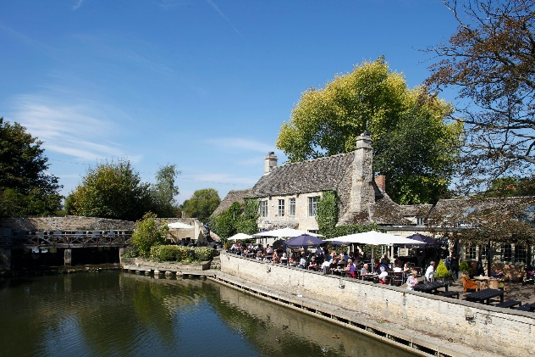

**ALSO -** There will be a walk on Wednesday 22nd November. Time and venue will be announced later.

**FUTURE EVENTS:**

**OFWI UPCOMING EVENTS FROM OXFORDSHIRE INSPIRES**

**A Day at the National Portrait Gallery**

16 Jan 2024, 08:30 – 18:00 Cost £33.

National Portrait Gallery, St. Martin's Pl, London

**About the Event**

We hope that you will join us on a day out at the National Portrait Gallery in London, browsing the wonderful artwork on display in its new surroundings. The Gallery re-opened in June 2023 following a transformational building project involving major refurbishment of the building and re-presentation of the entire collection of over 11,000 portraits, drawings, miniatures, sculptures and more than 250,000 photographs.

We are only visiting the public galleries; however, our visit will coincide with an exhibition of David Hockney drawings.

We hope to arrive at the Gallery by 11am and wend our way home at 4pm, so there will be plenty of time to have lunch in the café whilst you are there, or take your own packed lunch if you prefer.

**SECRET GARDENS**

Unearthing the story of Oxfordshire’s historic gardens

Time and Location

28 Feb 2024, 10:00 – 12:30

Thomas Hughes Memorial Hall, White Horse, Uffington, Faringdon SN7 7S

Cost £10 or £12 non members

Archaeologist Dr Stephen Wass will talk about the county’s early historic gardens and share with us the secrets of what archaeology can reveal about them. Amongst the gardens he has excavated, Stephen will tell us about the extraordinary seventeenth century ‘theme park’ in the gardens around Hanwell Castle, North Oxfordshire, and bring along some of the amazing artefacts he discovered. The presentation will also include discoveries made at the Enstone Marvels, Tackley Water Gardens and the mysteries of the gardens of Wadham College