WMWI MONTHLY NEWSLETTER – APRIL 2023

Hi everyone, my name is Margaret Partridge and I am now
producing our monthly newsletter. I hope to add a few items of
interest taken Oxfordshire Inspires. My hope is that you it will give
you all a chance to see if there are any future events/excursions
you might like to book

NEXT MEETING – WMWI
WHEN Tuesday 11th April
WHERE St. Margaret’s Institute,
Polestead Rd
TIME 7.30pm for 8pm start

Jane Finnerty will give a short talk about the resolution “Clean Rivers for people and wildlife
Followed by a quiz and a dingbats puzzle – hopefully all great fun.
Do you know what dingbats are ? They are a
pictorial representation of a word or phrase for
instance
STANDING MISS
Answer : A misunder-standing

There will be a raffle so please bring along
some money for buying tickets.

OUTINGS FOR MAY
Visit to Kelmscott Manor – which belonged to William Morris and which he called “heaven on earth”.
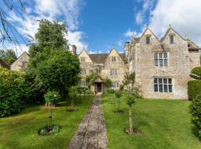
Date : Thursday 25th May
Entrance fee : £14.50
We will arrive by 10.30 and buy a coffee, then we will tour the place. This will be followed by lunch (at our own expense).
Please contact Hilary Godfrey (hilagodfrey@gmail.com) if you wish to come._______________________________
Visit to Farm ED – 101 acres devoted to sustainable farming, at Honeydale Farm, Shipton-under- Wychwood.
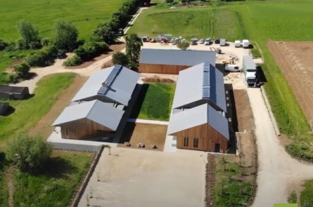
Date : Friday 5th May
We will arrive by 11 a.m. and have a tour and a lecture. This will be followed by a 2 course lunch.
Cost : £35 Please contact Hilary Godfrey (hilagodfrey@gmail.com) if you wish to come.
PAST EVENTS
OFWI ANNUAL MEETING 23/03/23
This was held for the first time at Worton Hall. I was your delegate and Hilary Godfrey and Ann Wiles accompanied me. The Treasurer’s Report included the news that the OFWI is still making a loss, but that this is expected to turnaround by this time next year. The Board are currently exploring finding new premises which should improve finances. The morning speaker was all about safeguarding against scams etc and we picked up some good tips. After lunch the winners of several competitions was announced. We were then introduced to Angela Gallop, CBE Forensic Scientist also having the label of Queen of Crime Solving.
What an amazing woman. She named some very high profile cases like Stephen Lawrence and explained how evidence is often linked to fibres, hair and of course blood.
At the end of the meeting we then said goodbye to our retiring chair Pauline Goddard

LAST MONTH’S MEETING
The Samaritans
We had a very interesting talk by Matt Williams who has been a volunteer with the Samaritans since 2009. He gave us the history of the organisation and said that there are 205 branches run by 17,000 volunteers

The Samaritan must be non-judgemental and must encourage the caller to talk, to unburden themselves. The Samaritan does not ever give solutions to the problems. He is there just to list Rarely do under 18 year olds end their lives. 75% of suicides are male – very often male, white, smokers or drinkers, in broken relationships, down on their luck. 80-85% of callers get what they wanted from the call to the Samaritans and only 15% say that the call was not what they wanted.
What an amazing job the Samaritans do.

OUR WALKING GROUP

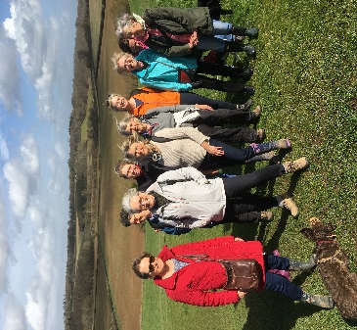

The Walton Manor walk took place on Wednesday 22nd of March.
We were 12 walkers on a beautiful Spring
morning as we set off

H’m should I swing or not!

from the pub at Church Hanborough, crossing the fields to Long Hanborough from where we headed down towards the river before returning uphill to cross the main road and made our way towards Pinsley woods.It was a lovely jolly walk of 4 miles.
The “doorstop” sandwich!
We finished back at the Hand and Shears pub for lunch and had a very long, much more than an hour long, wait for our lunch which was a bit of a blip. Otherwise a lovely day was had by all!
Thanks to all who the lovely ladies who make these days so enjoyable.
Hil Godfrey.
OFWI – EXTRACTS FROM
OXONFORD INSPIRES
Trip to Iford Manor Gardens, Wiltshire and Bath
Friday 19th May - £43 members which includes entry fee to Gardens
A wonderful day out in Bath plus the fabulous Iford Manor Gardens which includes a private talk about Iford

Trip to the Royal Forest of Dean with the Wye Valley Cruise
Thursday 20th July - £65 members.
Blue Badge Guide will accompany the coach. Visit Monmouth for free time and lunch. After which is a cruise along the River Wye. At the end of the cruise a cream tea is served at a nearby hotel. Leave at 4.45pm for home

.

