..
WMWI
The National Federation of WI’s campaign to
I improve women’s and family’s lives
Monthly Newsletter: February 2024: No 200
www.waltonmanorwi.co.uk

President: Caroline Coleman - 07850 830858
Secretary: Clare Wildish - 01865 556018 Walton Manor WI Treasurer & Vice President: Liz Jennings - 07717 756338 Registered charity 1119651

NEXT MEETING WMWI
WHEN Tuesday 13th February
WHERE St Margaret’s Institute
Polstead Rd
TIME 7.30 for 8pm start
SPEAKER – Graeme Gettings – Book folding practical

LAST MONTH’S MEETING
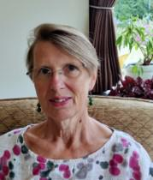
Our speaker was Katy Newell-Jones who described herself as an experienced consultant and facilitator with over 20 years of capacity building at individual, group and organisational levels in the UK and overseas. Her work overseas focuses on women’s empowerment, taking a holistic approach, recognising the links between access to health, education and opportunities for income generation,

peacebuilding, literacy and combatting gender-based violence including FGM/C.
She works with local non-governmental organisation to promote community development interventions which are evidence-based and use action research approaches, learning through on-going reflection and evaluation. Katy’s approach as a facilitator, researcher or evaluator is very different from the normal academic method. By engaging with the students she learns from them what it is they want from the course.
To demonstrate this she talked about her latest experience in a very, very poor area of Mozambique. Her first task before she went out to Mozambique was to learn Portuguese. She was introduced to a Mozambique organization called Micaia who focus on strengthening literacy and numeracy as a core element of their community development programme.

Her students were almost entirely girls and women. These females were sowing plants in the fields and after harvesting them had to sell them to traders.
They could not write their name to any invoices or keep records of their sales. Between 10 – 15% of them had never held a pencil!
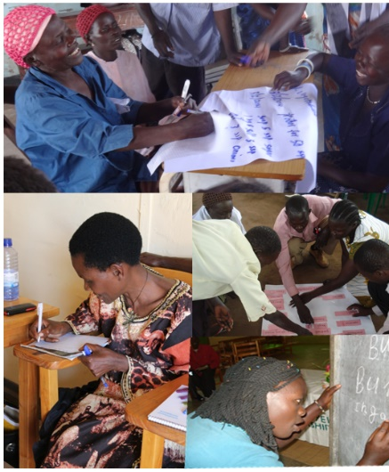
It was a very moving story and we were told that eventually they could write short sentences, manage money and could understand invoices. These women came together and made changes to their lives which enabled them to take these skills out to their villages

A note from Liz Jennings, Treasurer
LIMES CLUB, DAYBREAK, OXFORD
WMWI likes to support this local charity - Limes club, Daybreak Oxford, Living well with Dementia as they meet for members lunches at St Margaret's on two days per week. They provide an excellent focus and ongoing support for locals and their carers living with Dementia.
WMWI has donated £100 and this was their reply.
Hi Liz

What a wonderful way to start the New Year. You are amazing!

Thank you so very much for this continued donation to Limes Club. Thank you and to everyone at Walton Manor WI for remembering Limes during these festive season. We rely heavily on your donations to support our work here and your kind donation is extra special to us.

Why? because it helps us keep improving our work with cognitive stimulation therapy, including arts, crafts and music projects.

From all of our staff and volunteers - at Limes Club - A HUGE THANK YOU to Walton Manor WI!

LUNCH CLUB Eight members had a very jolly time at the Trout, Wolvercote. The food was good and we were able to have good conversation. Thank you to Di Williams for arranging this.
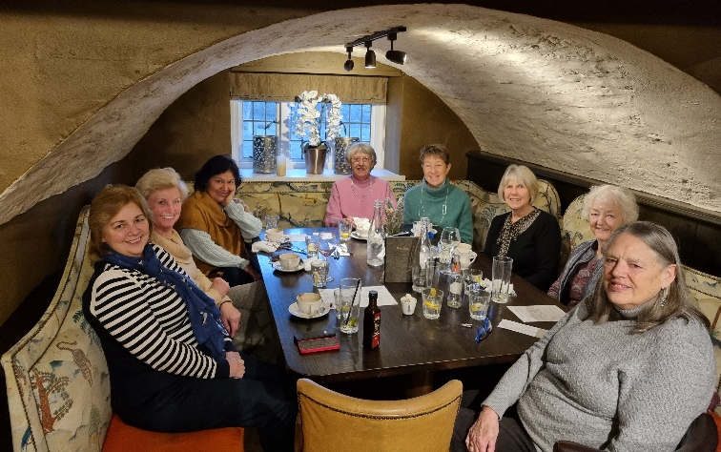
FUTURE EVENTS

Walton Manor Knit and Natter
The next Knit and Natter meeting will be
on Tuesday 20th February
from 7 – 9 p.m. at Catherine’s
92 Lonsdale Road, OX2 7ER.

Bring along your knitting, sewing, darning etc
and enjoy a coffee/tea and a good natter.

LUNCH CLUB – MARCH
This will be at the Turnpike,2 Woodstock Rd, Yarnton, OX5 1JP on Thursday 7th |March at 1pm. Please contact Di Williams if you would like to come.dianendave2@gmail.com
Cherwell Group Meeting
Tuesday, 16th April 2024 at 2.30pm
Yarnton Village Hall, The Paddocks,OX5 1TE (Yarnton WI)
David Allen speaking about The making of the Wizard of Oz.
Tickets are £4 available to purchase at our February meeting onwards.

OFWI-UPCOMING EVENTS

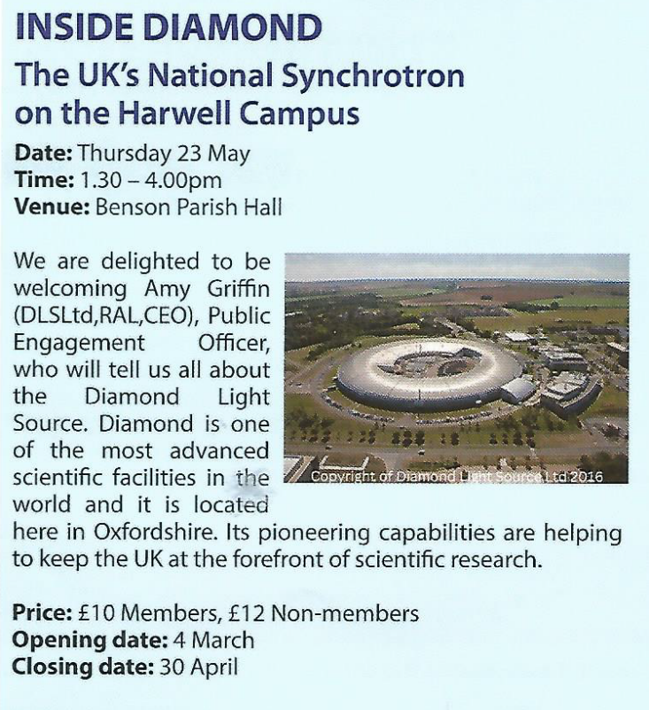

(see Bletchley Park below)

