WMWI
The National Federation of WI’s campaign to
Improve women’s and family’s lives

Monthly Newsletter: JUNE 2023: No 193
www.waltonmanorwi.co.uk

President: Caroline Coleman -07850 830858
Secretary: Clare Wildish – 01865 556018 Walton Manor WI Treasurer & Vice President: Liz Jennings – 07717 756338 Registered charity 1119651

NEXT MEETING – WMWI
WHEN Tuesday 13th June
WHERE St. Margaret’s Institute
Polstead Rd
TIME 7.30pm for 8pm start

Our speaker is Marcus Ferrar
Russia’s Disaster
Marcus Ferrar, author, communication consultant and trustee of several voluntary associations, was born and brought up in Britain. He lived for over 30 years in various European countries and now lives in Oxford. He holds dual British and Swiss citizenship. His father is British and his mother a refugee from Nazi Germany. He is a modern languages graduate of the University of London.
http:/www.marcusferrar.org/biog.html

LAST MONTH’S MEETING Emma Hamer, NFU – Why Farming Matters
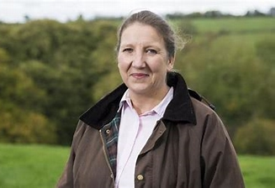

We are all aware of the saying “if you want a job doing, then ask a busy
person.” Well Emma is certainly a very busy person. On the day she came to
speak to our WI, she had been up since 4.30am and had completed many tasks on the farm, including feeding all the animals, before we had even had our breakfast! She and her husband own a 200acre farm but both have ‘other’ jobs outside of the farm.
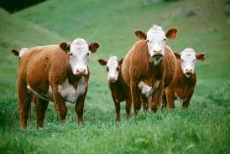

They keep Hereford cattle and 3 adorable lamas, which apparently look nice but don’t contribute anything to the working farm - although they can happily live outside all year round! They also borrow sheep for grazing at certain times of the year. Most crops are grown on the farm, eg oilseed rape, barley, wheat and others which provide forage for the cattle. They also have approximately 30 apple trees as well as several other types of fruit trees.
Emma’s knowledge on sustainable farming was quite remarkable. We were shown many slides of the animals, crops, trees and wild flowers but also the different pests that can damage the crops. Emma, who is a bio-chemist, was able to explain their reason for using different insecticides to prevent crops becoming resistant to just one type.

Emma explained that each field has a strip along the edge for the growing of wild flowers, orchard fruits and hedges.

British farmers create a countryside that works for everyone, providing the raw ingredients for a food and farming sector worth over £120 billion and employing over 4 million people. It provides a secure food system within our shores, feeding the nation and delivering a wide range of environmental and rural community benefits, all of which are enjoyed far beyond the farm gates. The UK is 61% self-sufficient.

She spoke about climate change, the importance of buying only British produce wherever possible and her work as an advisor to the NFU whose aim is to achieve net zero emissions by 2040.

FUTURE EVENTS

KNIT AND NATTER
DATE : Tuesday 20th June
WHERE : 92 Lonsdale Rd, Oxford
TIME : 7 – 9pm

We knit, sew, darn, embroider and natter over a cuppa. All WMWI members are welcome. Just turn up
Hostess is Catherine Dobson
Dobsoncatherine1@gmail.com

ALSO WI WALK
There is no walk planned for this month but hopefully we will be walking in July

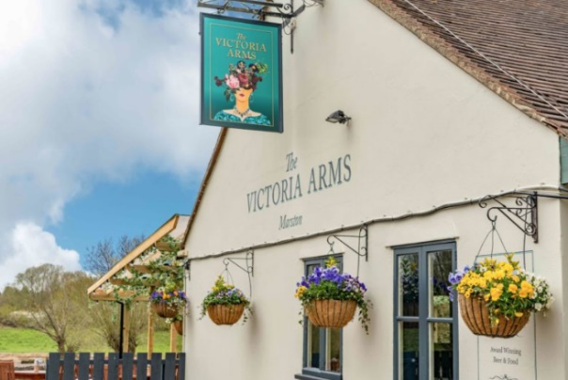

WMWI will meet for a pub lunch at
The Victoria Arms, Mill Lane, Old Marston. OX3 0QA
on Monday 26th June
at 12.30 p.m.
Please email Catherine on dobsoncatherine1@gmail.com
before Friday 23rd June if you wish to come.

OFWI UPCOMING EVENTS FROM OXFORDSHIRE INSPIRES
On Wednesday 13th September at Blewbury Village Hall from 10 – 3.30
Looking good, feeling great plus SWISH. Tips and ideas on how to look good. How to buy clothes that will a flatter. Advice on makeup. Plus OFWI are doing a Swish event.
Price £23 members £26 non-members

A day in historic Portsmouth
A day to explore or book yourself on a walking tour.
When Thursday 7th September
Cost £31 members £34 non members

