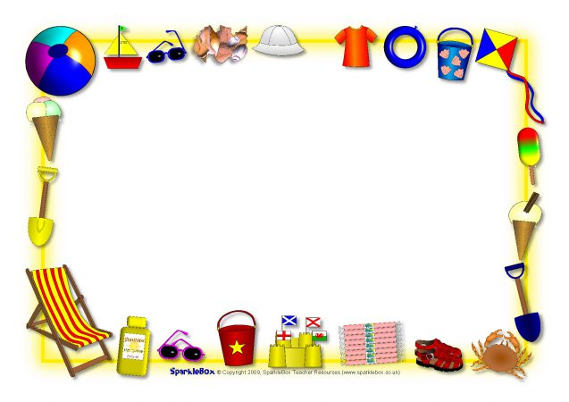
WMWI
The National Federation of WI’s campaign to
Im prove women’s and family’s lives

Monthly Newsletter: JULY 2023: No 194
www.waltonmanorwi.co.uk

President: Caroline Coleman -07850 830858
Secretary: Clare Wildish – 01865 556018 Walton Manor WI Treasurer & Vice President: Liz Jennings – 07717 756338 Registered charity 1119651

NEXT MEETING – WMWI
WHEN Tuesday 11TH July
WHERE St. Margaret’s Institute
Polstead Rd
TIME 7.30pm for 8pm start

Speaker is Sarah Bond Local artist who will talk and host a practical class. Sarah is a landscape painter, working mainly in oils, from her studio in Cumnor Village. Walking inspires her art, whether it is across the local countryside, along coastal paths, or high in the mountains. Recently her work has explored the effect of climate change on the natural environment and the positive aspects of renewable energy

LAST MONTH’S MEETING
Marcus Ferrar. Russia’s Disaster

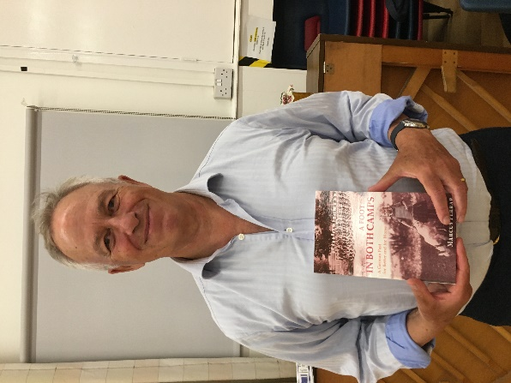

Our speaker for the evening was Marcus Ferrar Marcus Ferrar, author, communication consultant and trustee of several voluntary associations, was born and brought up in Britain. He lived for over 30 years in various European countries and now lives in Oxford. He holds dual British and Swiss citizenship. His father is British and his mother a refugee from Nazi Germany. He has lived for over 30 years in various European countries and was a foreign correspondent with Reuter. He began by explaining that together with a Russian author they had written a book on modern Russian and that as they were about to have it published Russia invaded Ukraine. His friend in Russia immediately removed all his details of the book from his computer and also all emails he had sent to Marcus.
He spoke about Catherine the Great who also took over Ukraine, Poland and Crimea which had belonged to the Ottoman empire. He reminded us that in the past Western powers had also competed against each other.
Russia has a population of 143 million and Ukraine 46 million. There is no doubt that this is a horrible war with terror being inflicted on the Ukraine people. The invasion was planned not by the Russian military but by the FSB ie the secret service. This meant that the army were not ready and had to galvanize the troops.
The effect on the west has seen a coming together of countries and also the recognition that America is undeniably needed to help.
Marcus went on to give us an insight into Vladimir Putin the man and how he has surrounded himself with like minded people.
China is willing to help a bit, but do not like the nuclear threat of Russian.
Democracy in Russian has been crushed and most of the people lead organizations have been closed down. Free media has also been closed down. Over 1 million Russians have left the country including many talented men and women. It is well known that if you are not for Putin you are very vulnerable and no doubt you are being “watched”
He concluded by saying that the Russians have been brainwashed and 50% of them don’t care about the war.

FUTURE EVENTS

The Knit and Natter group will meet on
Tuesday 18th July

KNIT AND NATTER
from 7 – 9 p.m.
at
92 Lonsdale Road OX2 7ER

Bring along any knitting, darning, crochet, sewing, embroidery – and above all YOURSELF for a good natter and a cuppa!
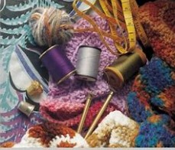
Catherine Dobson

ALSO

On Wednesday 2nd August Mikron Theatre will be performing A Force to be Reckonded With.
WHERE : The Plough Inn Wolvercote Green
WHEN : Wednesday 2nd August
TIME 7pm but suggest we meet up at 6pm so we can try and get a good positon
COST: A “pay what you feel” collection will be taken after the show
No reserved seating
Suggest you bring a fold up chair.
If you wish to order food, please ring 01865 556969 after 26th July. Web: www.theploughoxford.co.uk
See you there

