WMWI
The National Federation of WI’s campaign to
improve women’s and family’s lives

Monthly Newsletter: APRIL : 2024
www.waltonmanorwi.co.uk

President: Caroline Coleman -07850 830858
Secretary: Clare Wildish – 01865 556018 Walton Manor WI
Treasurer and Vice President : Liz Jennings – 07717 756338 Registered charity 111965

NEXT MEETING WMWI
WHEN Tuesday 9th April
WHERE St Margaret’s Institute
Polstead Road
TIME 7.30 for 8pm start
Voting for this year’s resolution followed
by a quiz or game

LAST MONTH’S MEETING

Our speaker for the evening was Alexandra Henden from the St Mungo’s Charity which gives support to homeless people in the major cities in the south of the country She explained that the vision of the charity is that everyone in the UK has a place to call home and bring about the end of homelessness.

The statistics for homelessness were quite staggering. The main reasons were:
Relationship breakdown
Past traumas
Mental health difficulties
Zero hours contracts
Life expectancy for men in this situation is 45 years whereas the normal man would live to 79 years
Similarly for women it is 43 years and the normal women would live to 83 years.
In Oxford, they have residential care for 20 people who can stay for 2 years.
Pets are allowed into the accommodation.
They provide a vast variety of help with their needs. They are currently supporting 412 individuals in Oxford

Walton Manor’ Annual Meeting
Our President Caroline, announced that the committee had agreed to serve for another year.
The Treasurer’s Report was read out as
Liz Jennings was unable to be with us.
We have a healthy balance of £1250.92 and there has been an increase in membership.
Our Secretary gave her report outlining all the various speakers and outings throughout the last 12 months.
Caroline then thanked all the people who had supported her.

THE INTREPID WALKERS
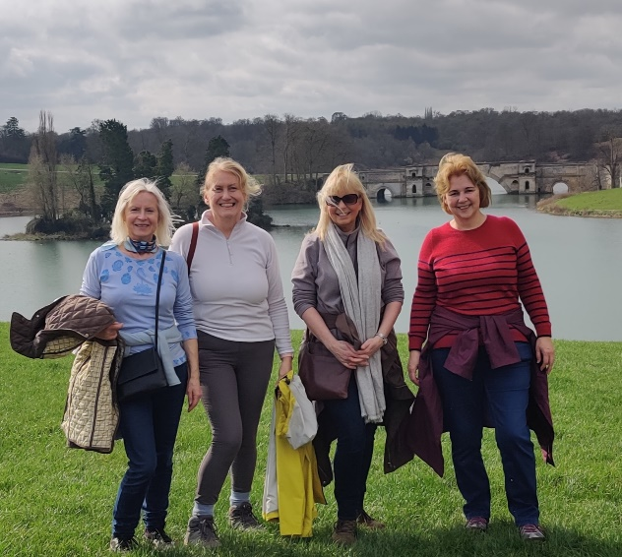

The first walk of the year was around the grounds of Blenheim Palace. A very convivial pub lunch was enjoyed afterwards at the Kings Arms.

Visit to the Diamond Light Source

Eight members went on a guided tour of this enormous, doughnut shaped plant. We were given so much hi-tech information that at the end of two hours, my brain ached!

Diamond Light Source is the UK’s national synchrotron. It works like a giant microscope, harnessing the power of electrons to produce beams of light that are 10 billion times brighter that the sun!! Scientists can use this to study anything from fossils to jet engines to viruses and vaccines.

Six members attended the Annual Meeting of the Oxfordshire Federation WI. It was good to hear that financially, we are in reasonable shape. Unfortunately the afternoon speaker pulled out, due to illness. Nevertheless the replacement was Claire O’Grady, Station Commander, RAF Brize Norton. Her talk included all the changes that have been achieved for women to have a fulfilling career in the forces.

FUTURE EVENTS

LUNCH CLUB
The next W. Manor WI lunch is booked for the 30th April 12.30 for 1pm at The Talbot Eynsham. Address Oxford Road, Eynsham OX29 4BT (This is the Farmoor road out of Eynsham before the toll bridge). We have been before and the food is usually excellent.
If you would like to come please let me know at dianendave2@gmail.com

WALTON MANOR KNIT AND NATTER
The next knit and Natter meeting will be Tuesday 16th April
From 7 – 9pm at Catherine’s
92 Lonsdale Rd, OX2 7ER
Bring along your knitting/sewing etc and enjoy a coffee/tea and a good natter.

Here is a list of future outings which Anne Cashmore is planning. If you are interested in any of these outings then please contact Anne (see below)
Sezincote House and Gardens ( Moreton -in -the -Marsh) .10 places booked for the 2pm 3rd July house visit( gardens included) . Members have already put their name down for the visit but I will contact Sezincote directly if we have more interest. It is a beautiful small Georgian mansion with an onion dome and Hindu themed garden. Entrance to the House is strictly every half hour and costs £15.
Tea and cake are served in the orangery.
Of note, Batsford Arboretum is across the lane. Those of you feeling so inclined and can manage a full day out may wish to incorporate that facility too!
Failing that I shall be organising an outing to the Oxford botanical arboretum at Nuneham Courtney at some point in the future.
The Cotswold Lavender Farm and distillery visit is set for Tuesday 16th July. Confirmation of this date to follow. Please contact Anne if you would like to go. As a variation on a packed lunch a picnic is suggested with lavender biscuits and ice cream to follow!
Ardley Recycling centre on Tuesday September 17th.This should be a fascinating experience and one that should help us decide what to recycle and what not! Again I will need definite names as there are some health and safety forms etc to be completed before this visit.
Anne
Anne.cashmore@hotmail.co.uk

